Biotechnology

Assessment Statements
- State that gene transfer between any organisms is possible as they share the same genetic code
- Describe how gene transfer is carried out with the aid of plasmids, restriction enzymes and ligases
- Outline why CRISPR/Cas9 is a very efficient tool in gene technology

Overview
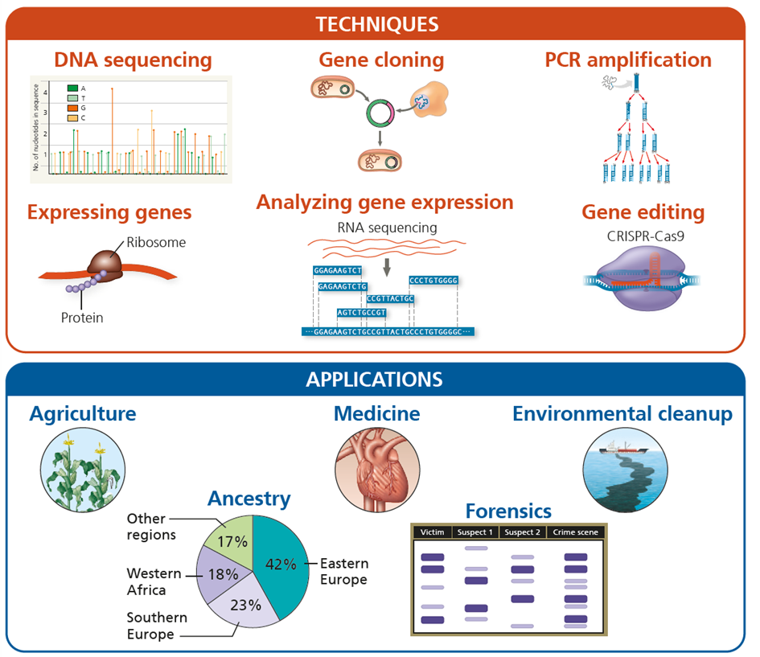

Color labels in biotechnology
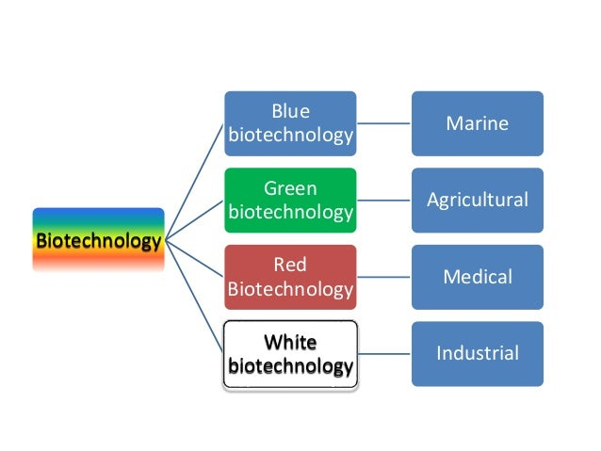

Paper Biotechnology Experiment
In this educational example (the sequences are not real), the goal is to produce the banana protein for flavor in large amounts. You will cut chromosomal DNA and plasmids and put them together to get bacteria producing the banana protein. You do all the necessary steps as a real scientist – just on paper. You may check this overview diagram before and while doing this task.
Plasmids are small circles of DNA (mini chromosomes) containing only few genes. They occur naturally in bacteria.
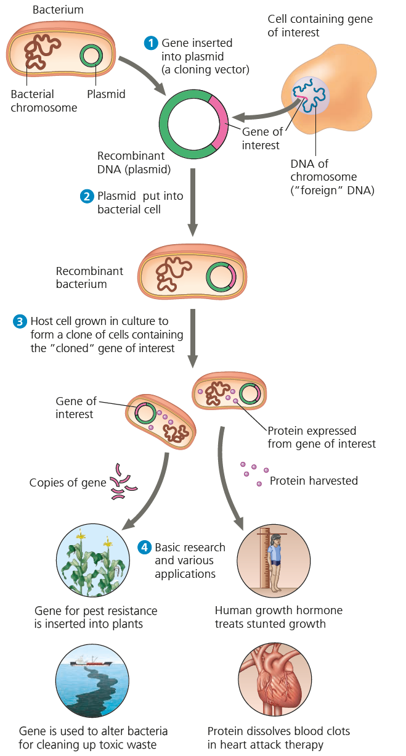

1 DNA extraction
The process of extracting DNA from the banana plant should be familiar to you, as you did this with your mouth cells in school some weeks ago.
Get the printout sequence of the banana gene and the plasmid. Check if you are still familiar with the base pairing rules.

2 DNA amplification
Quite often, DNA extraction doesn’t lead to enough DNA. This is especially true if the DNA is from very old samples (such as mummies and mammoths) or crime scenes (such as a few hairs on a table).
The Polymerase Chain Reaction (PCR) is a method to amplify DNA. With the help of artificially created small pieces of DNA (primers), scientist can control which region of the DNA segment will be amplified.
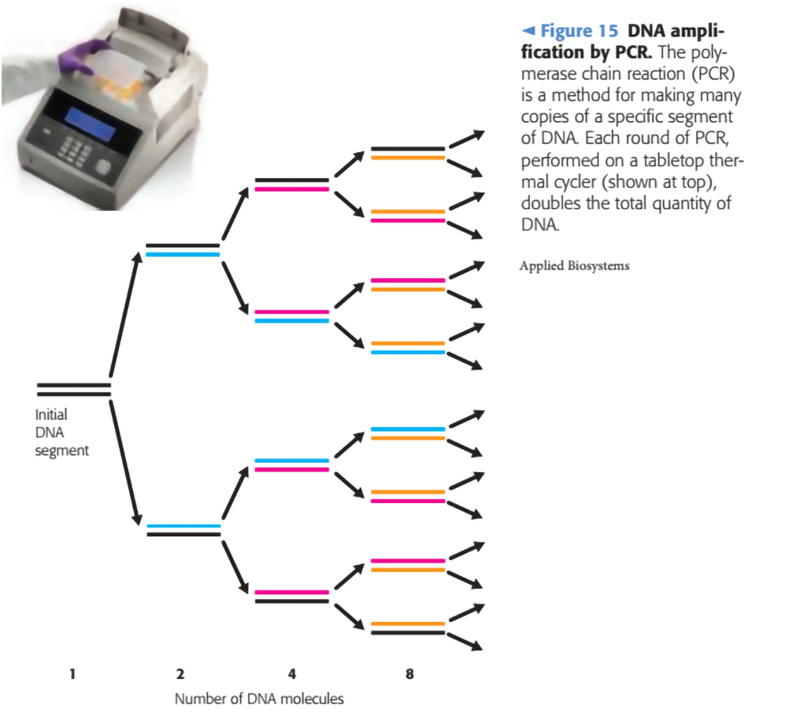
We assume we have enough banana DNA and don’t perform PCR on paper.

3 Restriction enzymes
Restriction enzymes occur naturally in different bacteria. They are part of the bacteria “immune system” to fight viruses. Today a huge collection of different restriction enzymes is known and commercially available for lab work. A restriction enzyme can be viewed as “molecular scissor” as it cuts DNA at a very specific recognition site. As an example, the restriction enzyme EcoRI looks for the sequence GAATTC and cuts it the following way:
--GAATTC-- --G AATTC--
--CTTAAG-- --CTTAA G--
As the cut DNA contains small regions of single strand DNA, this kind of restriction result is called sticky ends. There are also enzymes producing blunt ends, such as SmaI:
--CCCGGG-- --CCC GGG--
--GGGCCC-- --GGG CCC--
The name comes from the bacteria where the enzyme occurs naturally: EcoRI is found in Escherichia coli and SmaI in Serratia marcescens.
Take your banana DNA and cut it (with a real scissor) according to SmaI and EcoRI rules.

3 Plasmids
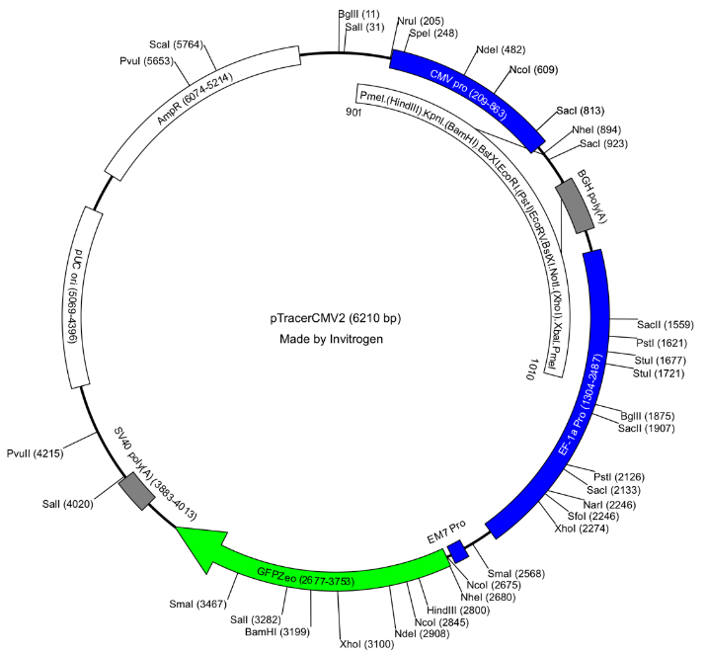
Most bacteria contain one chromosome which is much shorter than a human chromosome (bacteria do not have introns, so their chromosome is dense with genes). Most bacteria have additional plasmids: Very small, usually only few kbp (kilo base pairs, that’s an official unit) circular DNA fragments. They usually contain very few genes which code for optional features. There are plasmids allowing the digestion of specific carbohydrates or – medically important – the resistance against antibiotics.
In molecular biology plasmids are used to transport the desired gene. As bacteria replicate their plasmids when they undergo cell division, one can cultivate such bacteria and let them express the gene on the plasmid. On most laboratory-plasmids there are also regulatory genes so scientists can turn on and off protein expressions in the bacteria culture. Furthermore, plasmids can be isolated and stored for further use, serving as a gene library.
Here, you see the map of a real plasmid with few genes (boxes and arrows). It was made by a company which added that many restriction sites (lines).
Get a (much shorter) paper plasmid sequence and glue it together in a ring structure (see instructions on the sequence paper).
Now, search the sequence for restriction sites for EcoRI and SmaI and cut it (with a real scissor).

4 Ligation
Now, we have the desired gene and the opened plasmid. The next step is to put these together with a ligase. This enzyme glues together DNA strands. Ligases only work when the DNA ends fit, they cannot add or delete single nucleotides.
Do this ligation step with your paper sequences and adhesive tape.
Why are plasmids cut with two different restriction enzymes and not just opened with one?

5 Transformation
Many bacteria are naturally able to take up free DNA. This mechanism is called transformation and can be enhanced when bacteria are exposed to cold calcium-chloride solution followed by a heat shock (this makes the cell wall and membrane permeable for DNA).
A different mechanism is called electroporation. In fact, the name tells the mechanism: Bacteria are shocked with an electric current which creates small holes in their membranes.
As only few bacteria take up the plasmid one must select them from the unsuccessful transfers. This can be achieved by adding an antibiotic resistance gene on the plasmids. After transformation the bacteria are put in antibiotic enriched media. Only the ones which took up the plasmids survive and reproduce.
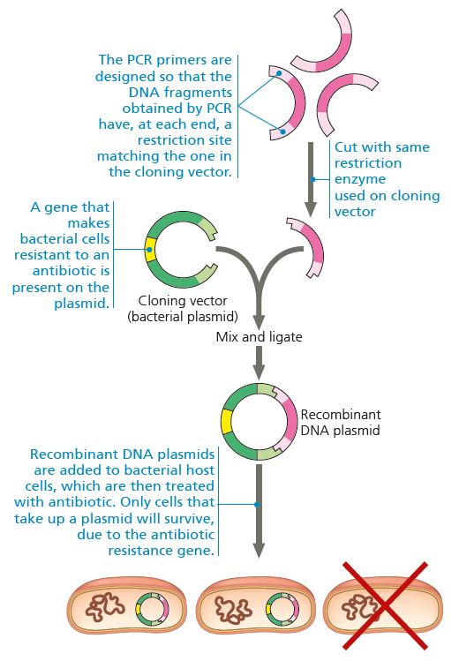
Today, antibiotic resistant genes are replaced with marker genes (the bacteria glow with UV light) or food depleted bacteria (they only survive with food genes on the plasmid). However, the mechanism is the same as in this old illustration.

6 Protein expression and purification
We now have bacteria with plasmids and our desired gene. If the plasmid has a “switch” it can be turned on (e.g. with lactose for the lactose operon). Bacteria are put in their food media and kept at their optimal growth temperature. They produce the desired protein in large amounts.
We now have our protein, but it is still in a mixture with all other bacterial proteins. One method is with the help of specific antibodies which are bound to a plastic tube. The cell content flows in this tube and only the desired proteins stick to the antibodies. Later they can be released from the antibodies and we get our protein without other ingredients.

7 Producing a transgenic plant
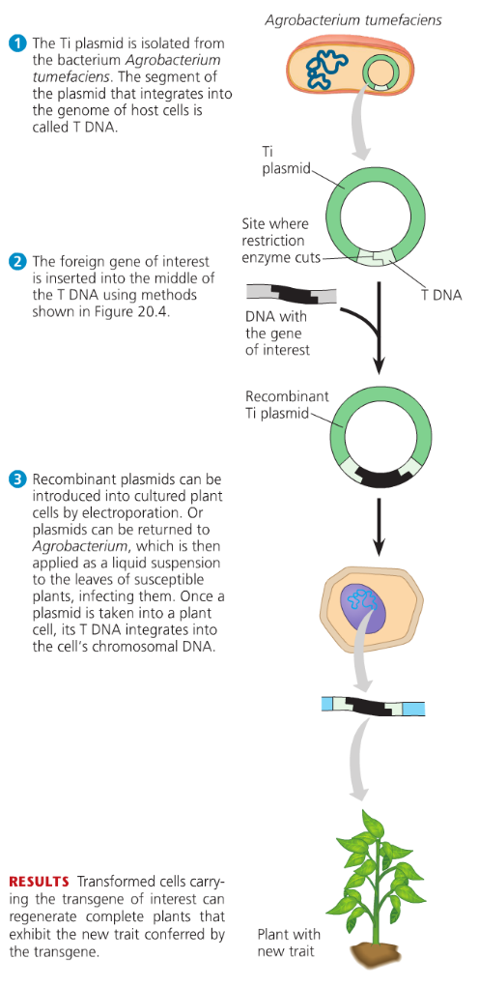
You just learned the process to get a transgenic bacterium. To do this for plants, the process is slightly more difficult (that means in theory, in the lab it is much more delicate).
Plant cells have massive cell walls and are normally not able to take up DNA by transformation. One brute but successful method is to attach the DNA to tiny gold bullets. These are shot into the plant. Few of the million bullets transfer the DNA into plant cells which are still vital. In some cases, the plant cell takes up the DNA and incorporates it into its genome. These cells can be selected and isolated to be the starting cell for a new plant.
A second method needs the help of the plant-pathogenic bacteria Agrobacterium tumefaciens. This bacterium can transfer its Ti-plasmid into plant cells. The plant is now forced to create food and a gall which hosts the bacteria. Scientists can include their desired DNA in this Ti plasmid, and they let the bacterium transfer the DNA into the plant.

Used Tools and References
- Reece, J. B. et al. (2008). Campbell Biology. (8th edition). Pearson Education.
- Reece, J. B. et al. (2021). Campbell Biology. (12th edition). Pearson Education.
- Sadroddiny, E. Biotechnology and Medicine. Accessed at 15.9.24 from https://de.slideshare.net/slideshow/biotechnology-and-medicine/61543062
- Simon, E. J., Reece, J. B., Dickey, J. L. (2013). Essential Biology with Physiology. (4th edition). Pearson Education.

CC BY 4.0 DEED for contents created by Daniel Margadant
For other sources (e.g., figures) please consider © of corresponding reference

